Alpaca trade

<https://github.com/alpacahq/alpaca-trade-api-python/>

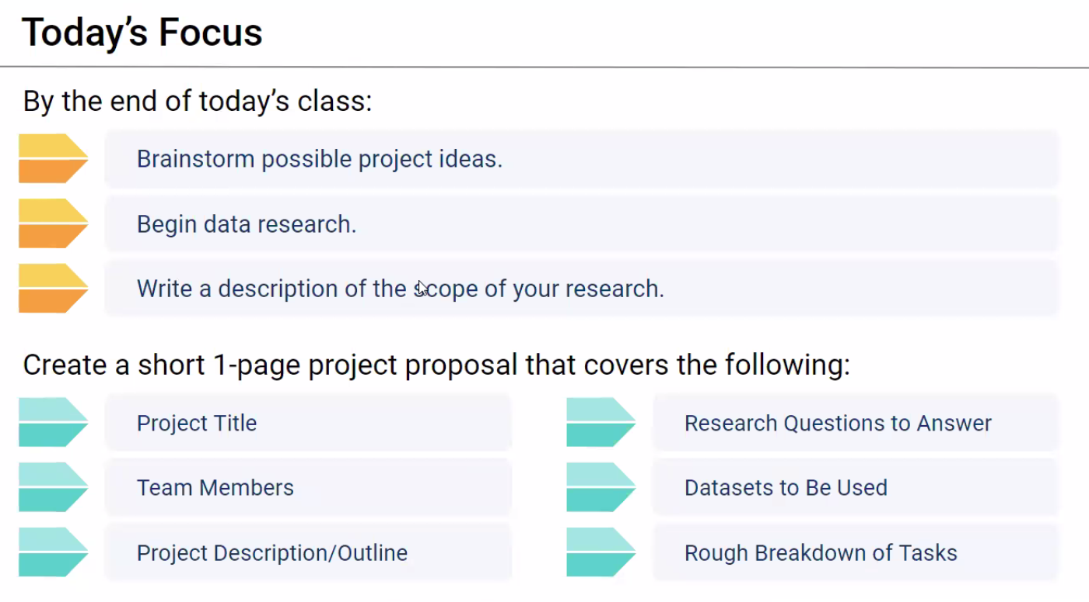

**Brainstorm possible project ideas:**

1. Real estate/property market (Fab)
   1. Migration data <https://www.abs.gov.au/statistics/people/population/overseas-migration/2022-23-financial-year#data-downloads>
   2. Housing data <https://www.abs.gov.au/statistics/economy/price-indexes-and-inflation/residential-property-price-indexes-eight-capital-cities/latest-release>
   3. Population data
   4. RBA interest rate/inflation data
2. Stock market/RBA/ABS (Lewis)
3. Energy sector (Simone)
   1. Big focus on carbon emissions in housing etc.
   2. ABS population <https://explore.data.abs.gov.au/>
   3. Victoria phasing out gas
   4. Carbon emission/temperature vs share price of utility companies
   5. <https://www.abs.gov.au/statistics/industry/energy/energy-account-australia/2021-22energy> data
4. <https://data.gov.au/home> generic data

***What Question we want to answer?***

***What data sources we have available?***

*If its free?*

*Type? CSV/API*

*Current? e.g. 2022 onwards*

*Quantity? (2 years of data)*

**Structure**

* Host of repo - Lewis

**Completed Analysis Uploaded to GitHub (20 points)**

**Visualisations (20 points)**

**Analysis and Conclusion (20 points)**

**Group Presentation (20 points)**

**Slide Deck (20 points)**

**Group Contact**

[lewis.trenerry@sapowernetworks.com.au](mailto:lewis.trenerry@sapowernetworks.com.au)

0450 471 526

[simonenagel@outlook.com](mailto:simonenagel@outlook.com)

0481 840 056

fsantos.vix@gmail.com

0424 209 690

lwjiang1015@gmail.com

0408 094 196